Year 2 Newsletter
Autumn 2019
P.E.  2D Thursday and Friday  2K Wednesday and Thursday  2L Monday and Thursday  Just a reminder that all children should have a Lisle Marsden P.E. kit with them on the relevant days for their class. As it gets colder, we still aim to be going outside so please ensure that your child has suitable outdoor kit, including trainers, as well as indoor kit. For safety reasons, long hair should be tied back and earrings should be removed or covered up with plasters brought from home.  Plimsolls  Most children now have a pair of plimsolls in school that they change into every day. This helps to keep our carpets clean, adding to your child’s comfort because quite a lot of our activities take place on the carpet. A big thank you to everyone for helping us with this.  Homework  Homework is given out each Friday and is due back by the following Friday. There will usually be something for literacy, maths and theme. It may involve a worksheet, an internet activity, or a conversation about the week’s learning. There will be a tray in each classroom where your child can put their completed homework.  We look forward to working with you and your child throughout the coming year. If you ever have any questions or concerns about anything at all, please do not hesitate to ask. | Theme  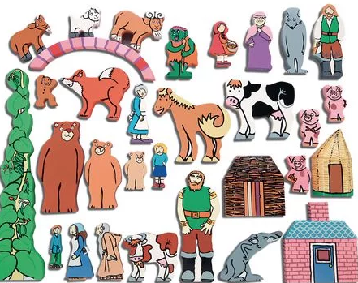  Our theme for this term is  ‘Fairy Tale Problems’.  Reading  Your child will take part in an adult-led guided reading session every week. They will then be given a book to read at home with you. When the book is returned the following week, they will be given another book. A new book cannot be issued until the previous book has been returned. The day that your child reads may change depending on what is happening during the week, and they may also read individually, so please make sure that your child always has their reading record and book in their bag.  Books with a Black Label  When your child is given a book by their teacher to read at home, they will also be given the opportunity to choose a book for themselves. This book will have a black label on it and may be at a different level to that which they are reading in class. This might be because they have chosen a more challenging text that they want you to read to them, or they might have chosen an easier text that they would like to share with a younger brother or sister.

