Year 2 Newsletter
Autumn 2 2019
New Theme  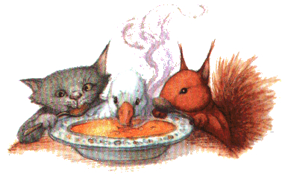  Our theme for this term is  ‘Pumpkin Soup’.  PE days this term:  2D Thursday and Friday  2L Wednesday and Thursday  2K Monday and Thursday  Remembrance    We will be visiting the Grimsby Cenotaph on Tuesday 12th November at 9.15. Thank you to everyone who has volunteered to walk with us.  Homework  A big thank you goes out to everyone for the impressive response to weekly homework that we have received so far this year. We look forward to it continuing this term. Do remember that it is up to the children to give us their homework rather than us checking their book bags for them. This is because we are trying to encourage a greater sense of independence and responsibility now that the children are in Y2. | Reading  Your child participates in a guided reading session each week so it is really helpful if they bring their reading record to school on that day. They also need to have read the book that was given to them the previous week so we can replace it with a new one.  Guided reading sessions are as follows:    2D Monday  2K Wednesday  2L Friday  Save the Dates  Tuesday 17th December will be Christmas party day for the children in Y2.  Wednesday18th December is the date of our annual school carol service at Grimsby Minster.  We will send more information nearer the time.

