Year 2 Newsletter
Spring 2020

Our theme for this term is:  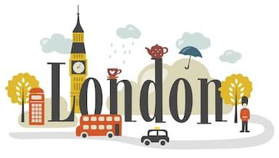  Let’s Explore  London  Knowledge Organiser  The first part of our theme has a geography focus. Each part of the term’s theme has its own knowledge organiser which sets out the knowledge that children will be learning about. The current knowledge organiser has been stuck into the children’s books for them to refer to throughout their learning. A copy is being sent to you with this week’s homework.  PE days this term:  2D Thursday and Friday  2K Monday and Thursday  2L Wednesday and Thursday  Guided reading days:  2D Monday  2K Wednesday  2L Friday  Please remember to bring your finished home reading book and your reading record to school on your reading day. It’s best if you keep your books in your bag all week in case we read at other times too. | Singing Festival    The whole of Year 2 will be taking part in the Key Stage One Singing Festival on March 4th.  ‘Sail Away’ is a musical story about best friends, Cosmo and Carrie. They go on a seafaring adventure in which they tackle one of the greatest issues of our time – ocean pollution. The day promises to be very exciting and will culminate in a performance at Grimsby Auditorium. More details to follow nearer the time.  Reading Challenge  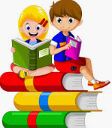  Our reading challenge for this term is called Read Around London. The sheet for recording your reading is included with this week’s homework. Every time you read with your child, fill in one of the boxes. When you reach a London landmark, your child should show their teacher and they will receive a certificate. When you reach Buckingham Palace, the final destination, your child will receive a prize.  Happy Reading

