
Year 5 Week beginning: 1st June
Tasks can be completed in the books in your folders, uploaded to your portfolio, sent in a message or via email.

Keep up the good Maths and English work
- Draw your name in straight lines, can you identify the different types of angles? Can you find a word which you could write using straight lines which has acute, right, obtuse and reflex angles?

- Test your maths skills at https://www.coolmath4kids.com/, we recommend Dirt Bike Fractions for comparing fractions!
- Continue logging on to TT Rockstars to improve your rock star status. Spend time developing your speed before rock slamming one of the Year 5 teachers.

- Read an extract of your favourite book and create at least 5 comprehension questions based on the text. Ask a grown-up to read the extract and answer the questions and then mark them. How did they do?
- Develop your writing skills by accessing an online lesson with Oak Academy:
https://www.thenational.academy/year-5/english/setting-description-write-a-setting-description-year-5-wk1-5
(There is a spelling test at the beginning of the session that you could try.)

- Continue reading on Bug Club, completing questions whenever you can. If you’re running low on books, just let us know.

DT
always make the dreams of children come true by designing and creating fabulous dens in their gardens. They have created fabulous dens of all shapes and sizes. If The Dengineers were to visit you, what kind of den would you want?

- Create a spider diagram or mood board of your ideas for your den.

- Draw a detailed plan of your den, think about both the inside and outside. Perhaps draw an aerial map and drawings to show the inside.

- Construct a model of your den using objects you can find around the house and garden. Think about the best materials and fixings to create your model den.

Science
- Investigate the planets of the solar system. How many are there? What are the different types? Which is the biggest? Which is the closest to Earth? How do they move around the Sun? Create a drawing to show the order and size of the planets in relation to the Sun.

- Select two different planets to research in detail and then present your findings. Consider the best way to present your research: a fact file, a report, a video etc.

- Write a written response to this Big Question: 

P.E
- Use the exercise below to develop different exercise routines throughout the week.
- Each day pick 5 different ones to create a routine, perhaps repeat your routine 3 times. Can you encourage other members of your family to get involved?
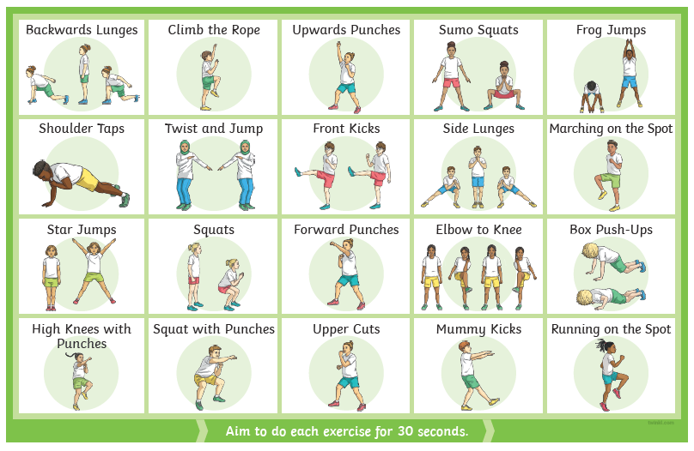

Those wanting to share their work whilst we are away from school can send photos/messages via dojo or email your class teacher.

mrs-dodds@lma.nelcmail.co.uk
miss-clarke@lma.nelcmail.co.uk
miss-hobbs@lma.nelcmail.co.uk

