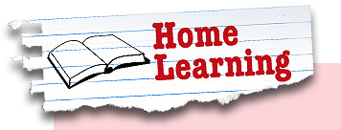
Year 5 Week beginning: 8th June
Tasks can be completed in the books in your folders, uploaded to your portfolio, sent in a message or via email.

Keep up the good Maths and English work
- 3D Shape Investigation – Go around the house and collect a range of items which you can use to identify their properties. You will need to draw a table ready to collect your information.

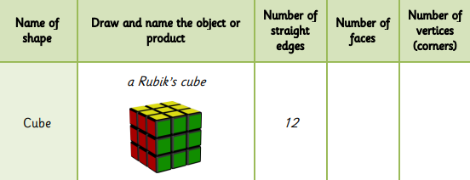

- Investigating Quadrilaterals – you will need to cut out 4 squares of paper to use for this activity. How many different ways can you make a rectangle, a parallelogram, a kite and a trapezium?

** You might need to remind yourself of what the shapes look like before you start**

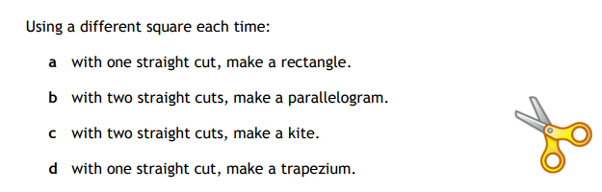

- Learn how to measure and calculate perimeter with this handy BBC Bitesize lesson - https://www.bbc.co.uk/bitesize/articles/zfhkd6f

- Use a formula to help you work out the area of a shape on BBC Bitesize - https://www.bbc.co.uk/bitesize/articles/zh9brj6

- Continue logging on to TT Rockstars to improve your rock star status. What is the highest score you can get in the Studio?

- Visit https://www.pobble365.com/ and look at the latest picture, if it doesn’t grab your attention flick back at the others as there’s a new one every day. Once you’ve had a good look at the picture and scroll down and complete the different activities:
        - Story Starter
        - Question time

        - Sentence Challenge
        - Perfect Picture
        - Sick Sentences

- Make comparisons within and across different books with this lesson from Oak National Academy - https://www.thenational.academy/year-5/english/story-reading-comprehension-to-make-comparisons-within-and-across-books-year-5-wk6-1

- Make predictions – what do you think will happen next? – with this lesson from Oak National Academy - https://www.thenational.academy/year-5/english/story-reading-comprehension-predicitons-year-5-wk6-2


- Continue reading on Bug Club, completing questions whenever you can. If you’re running low on books, just let us know.

PSHE
- Draw a gratitude tree. Start by drawing a tree and then add large leaves; in each of the leaves write something you are grateful for in your life. You might want to add more leaves as time passes.

- Draw a smiley face, or use a smiley photo, and make a list of all the reasons you laugh and smile. What always makes you smile? Who makes you smile every day? Who do you make smile?

- Spend some time reading some of the short stories and poems in ‘The Book of Hopes’ https://literacytrust.org.uk/family-zone/9-12/book-hopes/ Is there a particular part of the book you would recommend?

Science
- The Earth, Sun and Moon all play an important role in our day to day life. Create a colourful poster to show the key facts about each of these super spheres.

- Which one of these is the odd one out? Why?
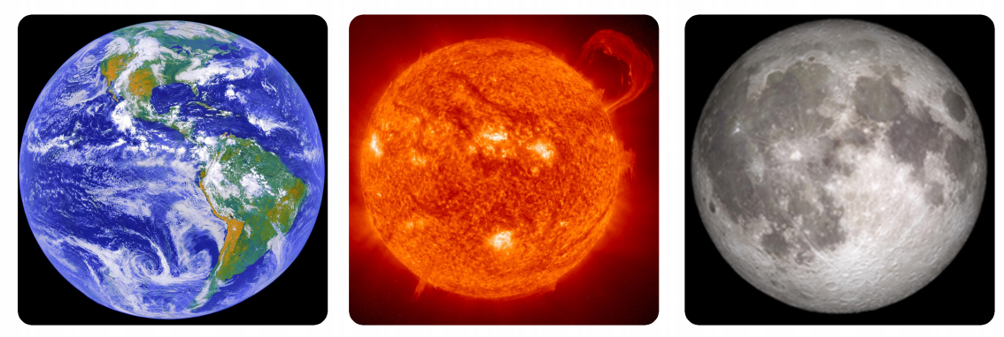

Can you give reasons for each one being the odd one out?

- Each month the moon goes through different lunar stages, on 13th June it will be in the last quarter. What does this mean? What are the lunar stages of the moon? Use drawings – or models – to show the different lunar phases of the moon.

P.E
- Spend time developing your Yoga skills. Have a go at each pose, how do they make you feel?
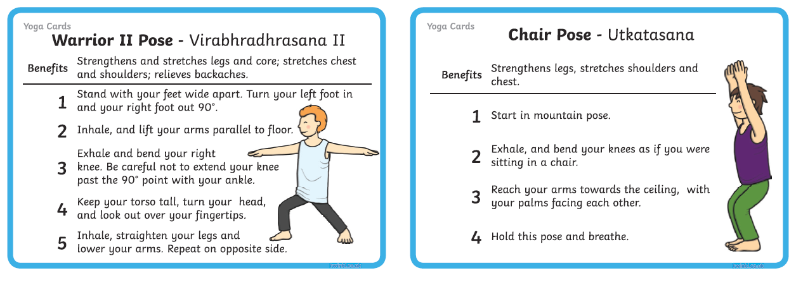
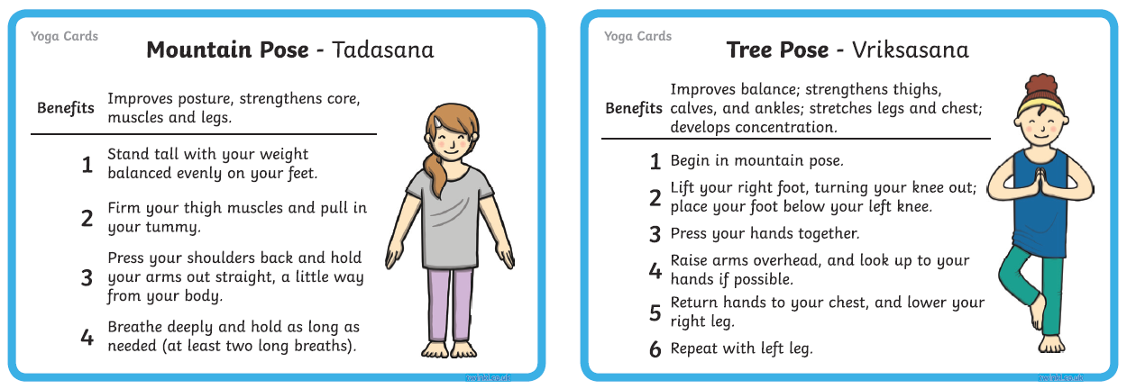
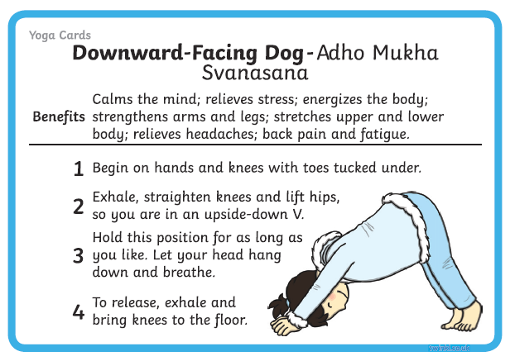
- Remember that there are lots of yoga videos you can join in with at https://www.youtube.com/user/CosmicKidsYoga


Those wanting to share their work whilst we are away from school can send photos/messages via dojo or email your class teacher/teacher looking after your home learning.
mrs-dodds@lma.nelcmail.co.uk
miss-clarke@lma.nelcmail.co.uk

