
Year 5 Week beginning: 22nd June
Tasks can be completed in the books in your folders, uploaded to your portfolio, sent in a message or via email.
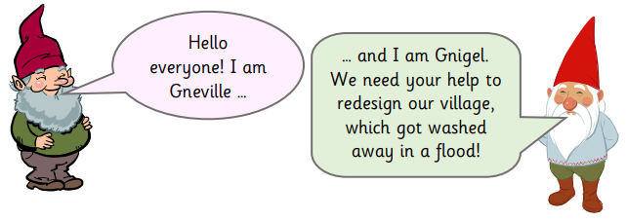
Maths

Gnome Gnumeracy: You will need to be ready with a sharp pencil and a ruler in order to help Gneville and Gnigel.
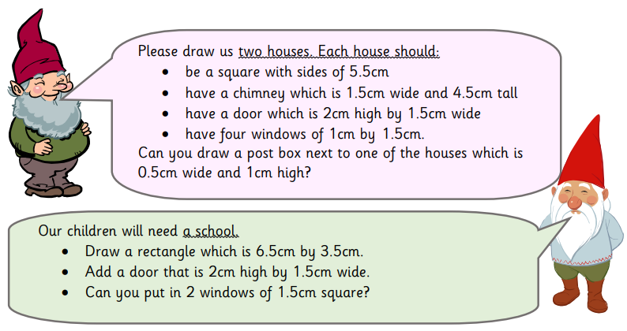

Use your knowledge of measures to complete the different online lessons at Oak Academy:
- Converting between units of length https://classroom.thenational.academy/lessons/to-convert-between-units-of-length
- Applying length conversions to problems https://classroom.thenational.academy/lessons/to-apply-length-conversions-to-problems
- Converting miles and kilometres https://classroom.thenational.academy/lessons/to-convert-miles-and-kilometres

Converting Units of Measurement:
- Converting measurements of length, mass and capacity can often be quite tricky, knowing whether to multiply or divide by 10, 100 or 1000 can be quite confusing.
- Can you create a learning aid to help others with their conversions? You could focus on length, mass or capacity or have a go at including all 3. Try to be creative, whilst posters are nice and colourful there are other creative ways to help others learn.

Daily 10
- Visit Top Marks every day to practise your mental maths! Select Level 5 and then choose which area of maths you want to have a go at. You can pick the time between each question and if you’re finding it too easy, challenge yourself to get quicker the next day! Find Daily 10 here - https://www.topmarks.co.uk/maths-games/daily10

- CHALLENGE – visit BBC Bitesize and have a go at the latest challenges for Year 5 https://www.bbc.co.uk/bitesize/articles/zbh4ydm

English

Read through the different Harry Potter scenario cards and have a go at the different tasks below.
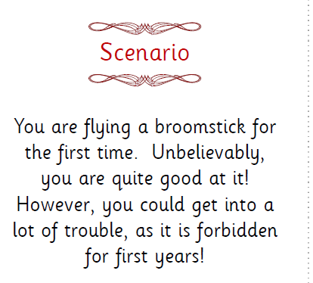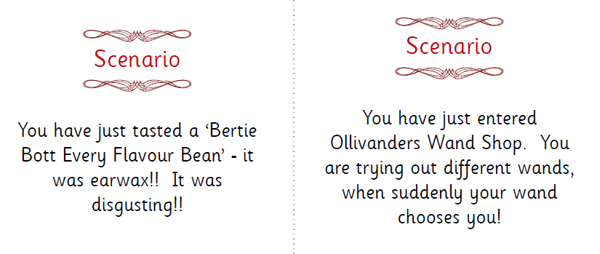

- Work with your family at home to act out the scenarios, perhaps film yourselves or take photos to create a comic strip.

- Write a playscipt for your chosen scenario, think about how to set out a play and remember to include stage directions.

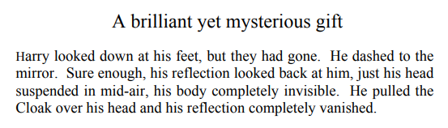

- Harry and his friends used the invisibility cloak for many different things. What would you use an invisibility cloak for? You might want to think about how you would use it if you were a character in a Harry Potter book and if you had one for your life today.

- Imagine you are the lead journalist for the Daily Prophet and the story of the century has been given EXCLUSIVELY to you. Create the front page of the newspaper. Think about the headline, the pictures and any other news that might make the front page.

Keep your reading skills in tip-top condition by completing the non-chronological report comprehension lessons online at Oak Academy:
- Lesson 1 - https://classroom.thenational.academy/lessons/reading-comprehension-word-meaning-d83aa0
- Lesson 2 - https://classroom.thenational.academy/lessons/reading-comprehension-word-meaning-and-fact-retrieval
- Lesson 3 - https://classroom.thenational.academy/lessons/identifying-the-features-of-a-text-d0fb0a
Science
- Most of us know that Neil Armstrong landed on the moon in 1969, but what else has happened over the years in terms of space exploration? Create an illustrated timeline to show the different events in space exploration history.

- Which one of these is the odd one out? Why?

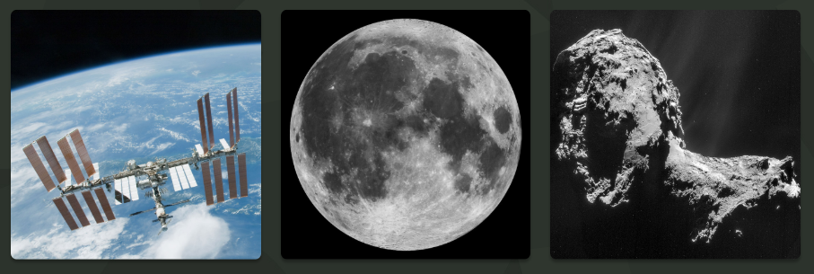
International Space Station the moon a comet

Can you give detailed reasons for each one being the odd one out?

- In recent weeks you have identified that the Sun is a star but what other stars are there? Watch this video to find out more https://www.youtube.com/watch?v=adKrNga8-Qs What was the most amazing fact?
- Explore the different constellations that can be seen in the sky, how many are there? Which are the biggest ones? Which one is your favourite?

P.E
Host your own ‘Home Heptathlon’ event by carrying out the following sporting activities.

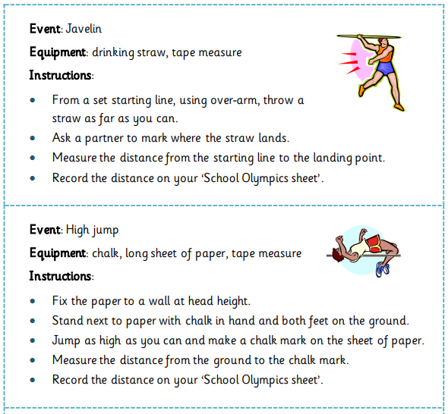

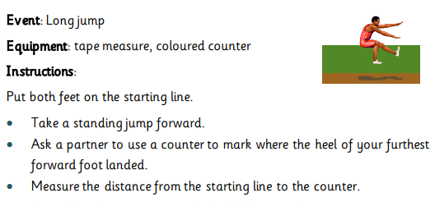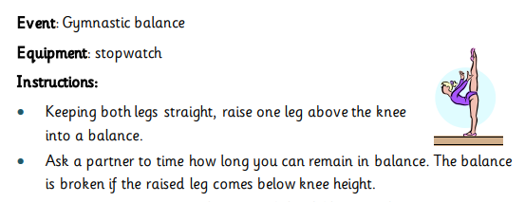

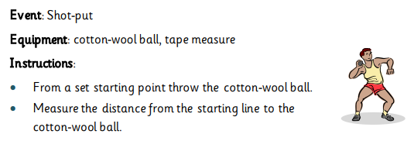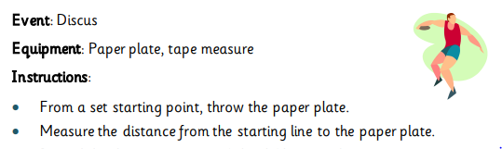

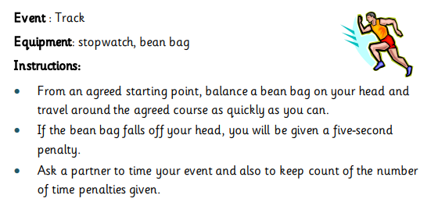


Those wanting to share their work whilst we are away from school can send photos/messages via dojo or email your class teacher.

mrs-dodds@lma.nelcmail.co.uk
miss-clarke@lma.nelcmail.co.uk

