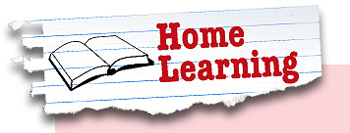
Year 5 Week beginning: 6th July
Tasks can be completed in the books in your folders, uploaded to your portfolio, sent in a message or via email.

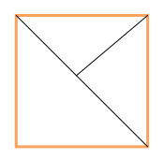
Maths
Box Puzzle:
- Draw a square 15cm x 15cm.
- Draw as many triangles as you can inside the box.

Rules: Each triangle must have one side exactly 4cm in length. No triangle is allowed to overlap another.
Four Triangles Puzzle:
- If you cut a square diagonally from corner to corner you get four right-angled isosceles triangles.
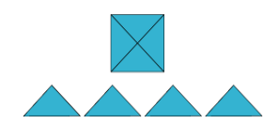
- How many different shapes can you make by fitting the four triangles back together?

Rules: You may only fit long sides to long sides and short sides to short sides. The whole length of the side must be joined.

- Think about how you will record the different shapes you make.


Refresh and reinforce your knowledge and understanding of shape by completing the online lessons:

- Identify, describe and classify shapes based on the properties https://classroom.thenational.academy/lessons/to-identify-describe-and-classify-shapes-based-on-the-properties
https://classroom.thenational.academy/lessons/to-identify-describe-and-classify-shapes-based-on-the-properties-6537fa
- Identify regular and irregular polygons by reasoning about equal sides and angles https://classroom.thenational.academy/lessons/to-identify-regular-and-irregular-polygons-by-reasoning-about-equal-side
- Identify, describe and classify triangles https://classroom.thenational.academy/lessons/to-identify-describe-and-classify-triangles
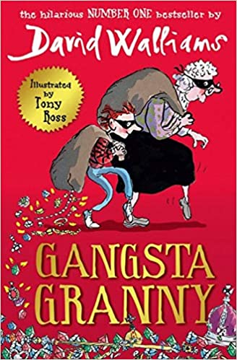
English
“Meet Ben’s granny. She’s very much your textbook granny:
- She has white hair
- She has false teeth
- She has used tissues tucked up her sleeve
- And … she’s an international jewel thief!”
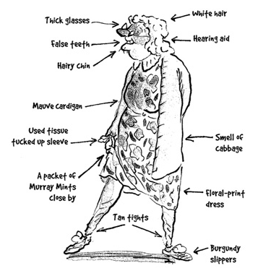

- This is how Ben sees his Granny at the start of the book, however, his picture of her changes as he learns more about her gangsta habits.

Draw a picture of what you think Ben’s grandad might have been like, bear in mind what he thinks about his Granny at the start.

- In Chapter 4 (page 43) Ben shows how to fool adults into thinking you have brushed your teeth by giving a list of illustrated instructions. Write your own set of illustrated instructions for a skill that you consider essential for all 9 and 10 year olds.
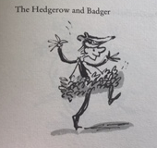
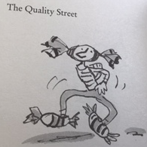
- Ben’s parents love to dance and want Ben to join in too wearing his own unique costume, his Mum’s ‘hand-drawn options ranged all the way from the embarrassing to the humiliating …’
Design your own dancing costume for Ben and decide what piece of music he would perform to.

- Create a comic strip to tell the story of how Ben and Granny stole the Crown Jewels. If you want to be creative, think of a completely different way they could have done it.
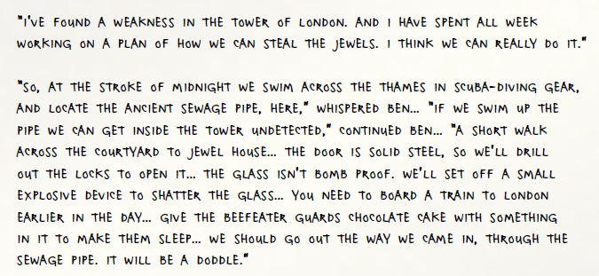
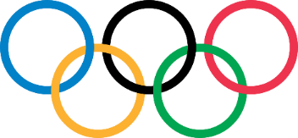
The Olympics

Last week you were asked to investigate the different torches that have been used as part of past Olympic ceremonies. Hosting the Olympics is a huge honour for countries, they put a lot of work into bidding to be the host and then into making sure that the whole event is something everyone – from around the world – will remember.

This week we are going to focus on the practical aspects of holding the Olympics, considering many of the things that need to be done before the games can begin.

- Every games Bronze, Silver and Gold medals are awarded to the winning athletes. Each country designs a new medal for the games.
  - How would you design an Olympic medal? Can you make it?
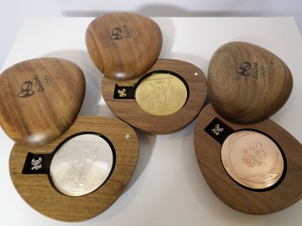
  - You might want to start by researching the different designs of medals which have been used in the past.
  - How were the achievements of the Olympic athletes recognised during the first modern Olympic games (1896)? How were they recognized during the ancient games?

- You need to make sure that everyone knows where the Olympics are being held and that the whole event will be AMAZING! With the plans for this year now changed, Tokyo needs to ensure that the event next year is a huge success for both the different sports and for their country.
  - Design an Olympic poster for Tokyo now it has been rearranged for 2021.

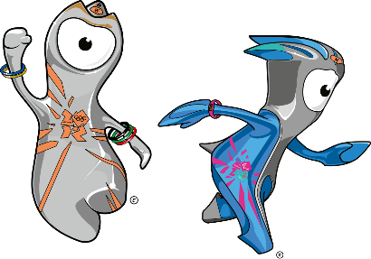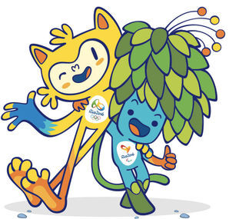
- Wenlock and Mandeville were the official mascots for London 2012, whilst Vinicius and Tom were the mascots for Rio 2016.
  - Who will be the mascots for Tokyo 2021? What can you find out about them?
  - Can you design new mascots for the next Olympics which will be held in Paris?


Those wanting to share their work whilst we are away from school can send photos/messages via dojo or email your class teacher.

mrs-dodds@lma.nelcmail.co.uk
miss-clarke@lma.nelcmail.co.uk

