
Year 5 Week beginning: 13th July
Tasks can be completed in the books in your folders, uploaded to your portfolio, sent in a message or via email.

Maths – Roman Numerals
- Create a learning aid to help you learn and remember how to read and write Roman numerals. Can you include some useful tips for reading tricky numbers?

- Cut out (or create your own) spinner and number board and challenge different family members to one of the Roman numeral games.

Game 1 - Spin the spinner to identify a Roman Numeral. Find a number on the grid matching the value of the Roman Numeral. Cover the number with a counter. The first to four in a line wins.
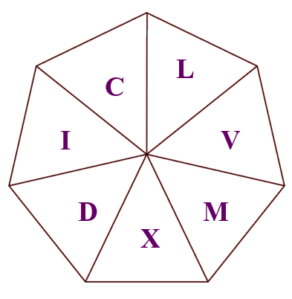
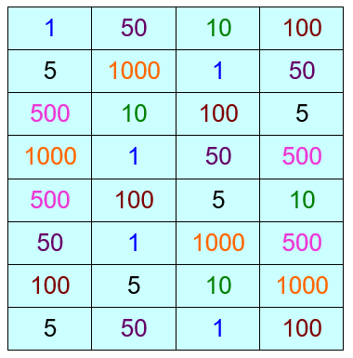
Game 2 – Cover all the numbers on the grid with a counter. Spin the Roman Numeral spinner to identify a numeral. Each player chooses to remove a counter to reveal a value. If a player’s value is more than the Roman Numeral on the spinner they keep their counter. If their value is less than that on the spinner they must put it back. First to collect 5 counters wins

Develop your knowledge and understanding of Roman numerals by having a go at these online interactive activities:
- Read Roman Numerals to M (1000) http://www.snappymaths.com/counting/romnum/interactive/readrntom/readrntom.htm
- Converting to and from Roman Numerals (to M) http://www.snappymaths.com/counting/romnum/interactive/romannumeralstoM/romannumeralstoM.htm


English

This week your task is to create a newspaper to report on the main events of the past year, the events from your time in Year 5. In your newspaper you will need to think about (you might want to include some or all of these):

  - The name of your newspaper
  - Your front page story
  - Catchy headlines that grab the reader’s attention
  - Photos and images
  - A range of new stories and events (good and bad)
  - Adverts
  - Book and film reviews
  - Games and puzzles
  - Sporting news
  - Horoscopes
  - Q & A page

* There may be some pictures on Dojo or on our class pages of the website which might help to jog your memory.

If you need some help with recapping the features of newspapers, perhaps have a look at this before you get started: https://www.bbc.co.uk/bitesize/topics/z2yycdm/articles/z2gk9qt



The Olympics

This week our Olympic focus is on the events and the athletes, the things which draw big crowds to stadiums and viewers to their TVs.

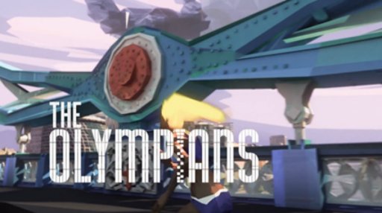
- Watch the video clip https://www.teachingideas.co.uk/greeks/the-olympians
Write an action poem to describe what is happening, think back to the fantastic work you did on your poem about ‘Changing Britain’ (which we based on the video of the opening ceremony of the London 2012 Olympics).

- Which Olympic event would you choose to compete in? Why? Challenge yourself to recreate this event at home. Perhaps have a go at doing other events at home with your family.

- When competing, all the athletes look very professional and ready for action in their team kits to represent their countries. As well as the kit they wear to compete in, they have training gear, hats, swimming caps etc. Your task is to design a new kit for your chosen sport, think about what it looks like as well as how practical and comfortable it needs to be.

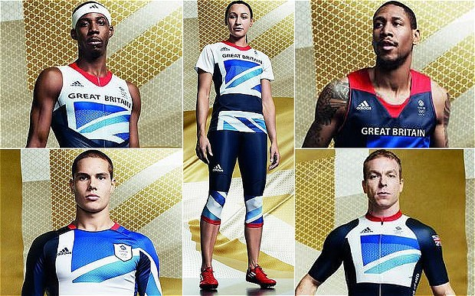



- Research a gold medal winning athlete from London 2012. Find out about their event, sporting history and achievements. Consider the best way to present your research.

- Who is the best Olympic athlete of all time? Why? Perhaps ask some family members who they would consider the best, you might all have very different answers and reasons for your choice.


Those wanting to share their work whilst we are away from school can send photos/messages via dojo or email your class teacher.

mrs-dodds@lma.nelcmail.co.uk
miss-clarke@lma.nelcmail.co.uk

