 | Lisle Marsden Church of England Academy
 | Year 3 Autumn Term 2 LONG TERM PLAN
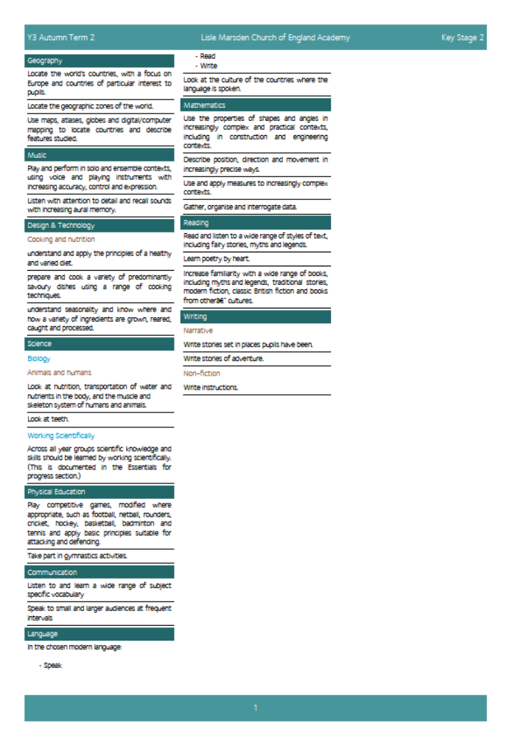
Lisle Marsden Church of England Academy
Year 3 Autumn Term 2

Sparkling start  A forest adventure |  |  | Who’s afraid of the big bad wolf? |  |  |  | Fabulous finish  Outdoor banquet – seasonal soup
Big Ideas | Wolves as inspiration  Plan a trip to the forest identifying the purpose of the adventure and resources that would be needed.  As adventurers, know what lives in the forest of England, Wales, Scotland and Ireland. Explore local woodland to discover what lives there.  As Geographers, discover where wolves live across the world. Compare and contrast countries. Also identify the language of that country and learn words around the wolf from that culture. http://www.wolf.org/  As scientists discover the species of wolves, environments and habitats that different wolves live in.  Explore wolf poems and learn by heart as part of a performance poetry in front of small and large audiences.  Compare and contrast the teeth of wolves to purpose and adaptation. Explain and connect how to wolves keep their teeth healthy. Contrast human teeth structure and hygiene to that of the wolf. Discover the use for teeth connects with diet and habitat.  Explain how our skeleton is linked to our muscles. Compare the muscle and skeleton systems of humans and wolves.  As writers compare versions of traditional tales with ‘The True Story of the Three Little Pigs’ by Jon Scieszka. Create information posters on different species of wolves, using an agreed criteria for categorising each species such as Endangered ratings.  As readers explore traditional tales and Grimm’ fairy tales, portraying the wolf as a villains through a range of books, including stories from other cultures. (Hugh Lupton – Story Tree)  http://thefairytalecupboard.blogspot.co.uk/2010/02/profile-big-bad-wolf.html  As mathematicians map distance, population, statistics to represent each chosen wolf species.  Discover how the wolf is portrayed through a variety of religions and cultures. Compare, contrast and explain how different cultures represent the wolf either as a warrior or as ‘the devil’ |  |  |  | Inspired by wolves  As musicians discover who Sergei Prokofiev was. Find out about where in the world he lived, his life and build a profile of this composer.  As learning detectives, discover and question understanding of the story and background to Prokofiev’s piece “Peter and the wolf”. Explore the 2006 animation Peter and the wolf directed by Suzie Templeton to raise questions and explain the music and the story.  As musicians listen to and understand the representations of characters through different instruments. Cincinnati Symphony Orchestra Listening map here.  As readers, explore the book ‘Beware of Boys’ by Tony Blundell. Use story and listening maps to structure, sequence, connect and compose music to illuminate and personalise.  As Scientists, discover and explain how food and nutrients are transported around the body once eaten.  As designers, design and make their own soup for survival in the woods. Identify healthy foods, use and impact on the body of salt. Set a criteria for a survival soup or soup from another country.  As writers, discover the history to the recipe for the chosen soup, include steps to being successful (cooking outdoors) and publish as a year group book.  As computer experts take digital images to include within the writing to illustrate significant points in the cooking process.
Further opportunities | Readers: | Discover new knowledge about wolves through information books and use this to communicate new learning.  Explore poems and learn them to heart.  Read a range of traditional tales and compare the story structures and map the events
Further opportunities | Writers | Use information to build a picture of the wolf population using geographic, historical and scientific vocabulary.  Use sources of evidence from the past to present day to write and summarise the future for wolves.  Write stories
Further opportunities | Communicators: | Explain their understanding of wolves through non-fiction, poetry and story writing.  Discuss and debate the way wolves have been represented over time. Is this fair?  Perform poems in front of small and large audiences
Further opportunities | Mathematicians: | Measure distance and time. Gather data on the wolf and represent in tables and graphically.
Curriculum Drivers | In our Spiritual and Moral development we will: |  |  | Through Enquiry we will: | Through the Arts we will: |  |  | Through exploring Knowledge of the World we will:
Curriculum Drivers | Learn through fables to understand consequences and the moral behind the Boy who cried wolf.  Encouraging pupils to explore and develop what animates themselves and others.  Discover the different representations of the wolf in different cultures.  Should we vilify or protect the wolf? |  |  | Ask questions and discover new knowledge about wolves and apply this to understand their plight in a modern world.  Understand the way wolves area represented in science, religion, art and music.  Find out how food is transported around my body. | Study and know about the life and work of Franz Marc, the painter of animals http://www.franzmarc.org/  Study and know about the life and work of Sergei Prokofiev |  |  | Know about the geographic locations of the world and the habitats that wolves live in.  Explore the reduction in wolf populations and track environmental impact and human intervention to save species of the wolf from extinction
Secrets of Success: Attitudes | Try new things  • I enjoy new things and take opportunities wherever possible.  • I have found my Energy Zone – Things I love doing.  • I get involved in clubs or groups.  • I meet up with others who share my interests in a safe environment.  • I know what I am good at, but know there are lots of other things in the world to try out. |  |  | Don’t give up  • I think of new ways to do things if my first idea doesn’t work out.  • I get upset when I fail, but find ways to bounce back.  • I stick at things even if they are tough.  • I look out for luck and I think I am lucky. |  | Imagine  • I have lots of ideas.  • I am prepared to be wrong.  • I know which ideas are useful and have value.  • I act on my ideas.  • I ask lots of questions.

Lisle Marsden Church of England Academy: Connecting and sequencing learning
Year 3 Autumn Term 2
Sparkling start  A forest adventure | Who’s afraid of the big bad wolf? |  |  |  |  |  | Fabulous finish  Outdoor banquet – seasonal soup
Weeks (delete as needed)
Readers
Writers
Mathematicians
Communicators
Scientists
Religious Education
Computing
Design Technology
Geographers
Historians
Musicians
PSHE
Physical Education

