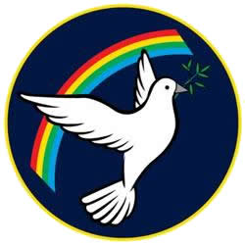 | Lisle Marsden Church of England Academy
 | Year 4 Autumn Term 2 LONG TERM PLAN
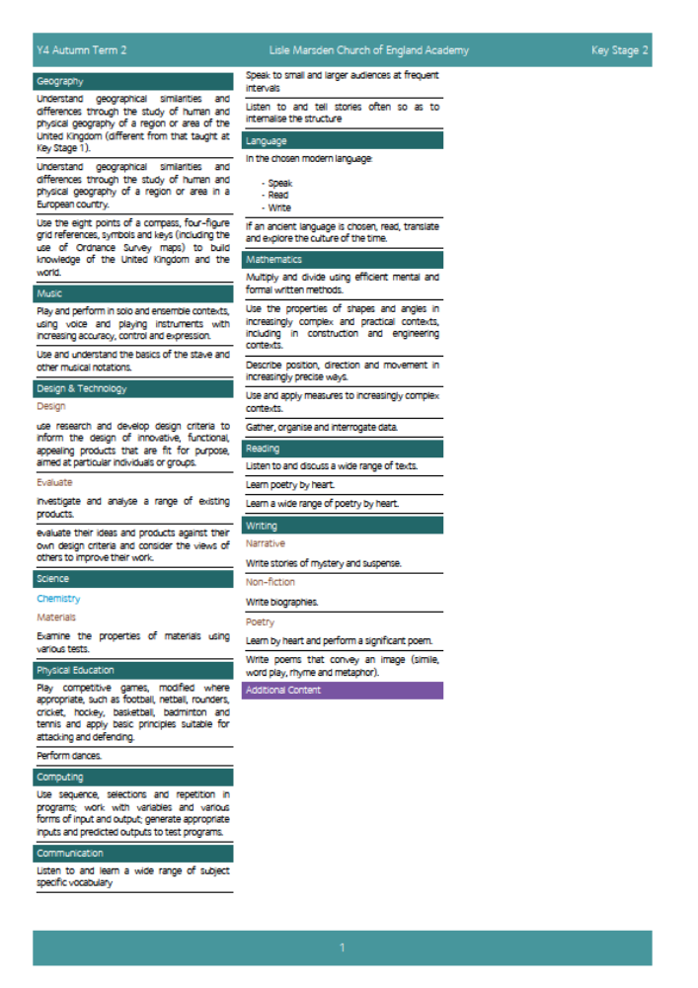

Lisle Marsden Church of England Academy
Year 4 Autumn Term 2

Sparkling start  Entering the land of Narnia through our classroom |  |  | Mysteries of Narnia |  |  |  |  |  | Fabulous finish  Geography showcase - Narnia maps and 3D islands
Big Ideas | As Readers we will discover the connection between real world events of the Blitz in London and an imaginary world through the wardrobe.  We will explore the factual elements of the story and use them in our writing to contrast the imaginary world we create.  Through uncovering the four main characters we will compose and create our own personalities, descriptions, settings based on imaginary creatures.  As Writers we will compare and contrast different characters, analysing their personalities, traits, habits, beliefs and lifestyles. We will construct our own imaginary characters based on a C.S. Lewis’ writing and publish them to the school.  We will recognise the differences in the way it is interpreted between the book – The Lion, the Witch and the Wardrobe and the film.  As Mathematicians we will measure distance, use scale, perimeter, use co-ordinates, create problems based on time and scale (using maps)  As Scientists we will explore evaporation and the water cycle in context of real environments and our imaginary ones. Through discovering rocks on our island we will identify, classify and sort them into igneous or sedimentary.  Explore real life fossils and explain how they have formed and the environmental factors that led to them being created. |  |  |  |  | As Geographers we will map the imaginary world of the Narnia, using physical and human geographical terms. We will connect places in the world with similar features and use them to exemplify the imaginary world  As Artists we will use the clothes the characters wore to inspire our textile designs. We will use a range of materials to make costumes for our own characters and imaginary creatures. We will use a range of stitches to connect materials and create effect.  We will sculpt masks to bring our characters to life using modrock and sculpting techniques. These will be based on the detailed descriptive language taken from our writing.  As Computer experts we will use graphics and computer programmes to create our imaginary characters. We will take part in secure online blogs(that are moderate by teachers) within the class to evaluate and identify aspects that we like about a character and how to successfully let someone know how to improve, without causing offense.  Through Design Technology we will construct our maps and islands and maps using physical geography terms to replicate our maps. We will discover methods to mould, sculpt and  Through Music we will listen to orchestral pieces, identify and recognise music that convey suspense, action and calm. We will connect music with emotions and as another layer to communicate authorial intent.  Through PSHE ( Relationships / Wider World) we will realise the nature and consequences of discrimination, teasing, bullying and aggressive behaviours (including cyber bullying, use of prejudice-based language, how to respond and ask for help)
Further opportunities | Readers: | Read and take inspiration from C.S. Lewis’ Lion, Witch and Wardrobe. Discover new characters, personalities and beliefs that shape the story.
Further opportunities | Writers: | Use imaginary characters and those from the book, to write stories of mystery and suspense.
Further opportunities | Communication: | Read, role play and explain the sequence of events, character actions and consequences that bring the story alive. Read poems about Narnia
Further opportunities | Mathematicians: | Use measures to represent our models accurately – considering proportion, scale and number
Curriculum Drivers | In our Spiritual and Moral development we will: |  |  |  | Through Enquiry we will: |  | Through the Arts we will: |  |  | Through exploring Knowledge of the World we will:
Curriculum Drivers | provide a clear moral code as a basis for behaviour which is promoted consistently through all aspects of the school;  promote racial, religious and other forms of equality;  give pupils opportunities across the curriculum to explore and develop moral concepts and values – for example, personal rights and responsibilities, truth, justice, equality of opportunity, right and wrong;  develop an open and safe learning environment in which pupils can express their views and practise moral decision-making;  reward expressions of moral insights and good behaviour;  make an issue of breaches of agreed moral codes where they arise – for example, in the press, on television and the internet as well as in school; |  |  |  | Be curious about the motivation that drives significant characters in the book.  Ask questions to deepen understanding of a place, character or person.  Explore the process of fossilisation and look for answers to the questions we come up with. |  | Use stitching and a wide range of materials to make an outfit that communicates the personality and traits our chosen character holds.  Explore the impact music has on creating effect for the viewer / reader.  Compose, practice and present a dance based on Narnia and one of our characters |  |  | Know about the different rocks and how they are formed. We will use this to make accurate models of our maps, using scale and ratio to convey proportion.  Describe, compare and contrast real places with those of our islands using geographical language
Secrets of Success: Attitudes | Push yourself  • I find a way to push myself even when things are difficult.  • I push myself in lots of ways… even things I don’t feel like doing.  • I listen to other people who push me, and thank them for their advice.  • I know that pushing myself makes me better at things. |  |  | Don’t give up  • I think of new ways to do things if my first idea doesn’t work out.  • I get upset when I fail, but find ways to bounce back.  • I stick at things even if they are tough.  • I look out for luck and I think I am lucky. |  |  |  | Work hard  •I have fun working hard.  •I know that by working hard I will be successful.  •I keep practising even when I am good at something.  •I encourage others to work hard.  •I give my best effort to everything I do.

Lisle Marsden Church of England Academy: Connecting and sequencing learning
Year 4 Autumn Term 2
Sparkling start | Mysteries of Narnia |  |  |  |  |  | Fabulous finish
Weeks (delete as needed)
Readers
Writers
Mathematicians
Communicators
Scientists
Religious Education
Computing
Design Technology
Geographers
Historians
Musicians
PSHE
Physical Education

