 | Lisle Marsden Church of England Academy
 | Year 4 Spring Term 1 LONG TERM PLAN
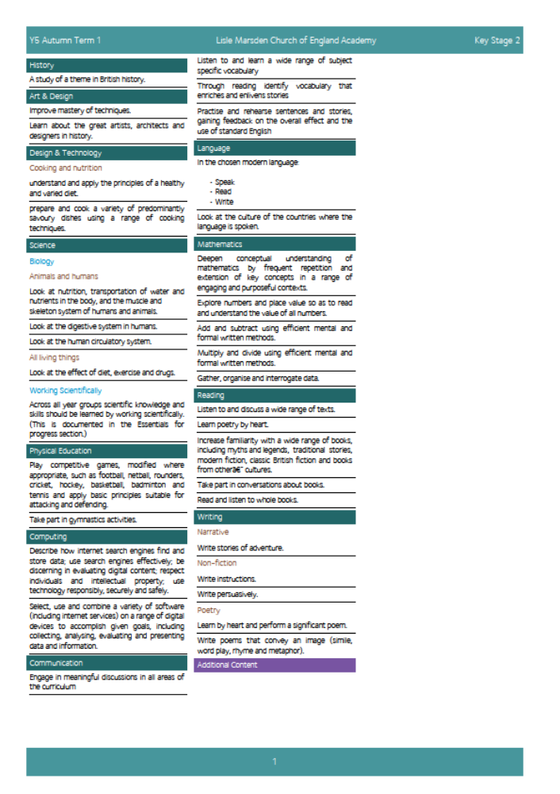

Lisle Marsden Church of England Academy
Year 4 Spring Term 1

Sparkling start  Visit Thornton Abbey |  | Were the Tudors that terrible? |  |  |  |  |  |  |  | Fabulous finish  Tudor portrait show throughout the school.
Big Ideas | As Readers we will study a wide range of non-fiction information using books, the internet and artefacts as sources of evidence. We will use this evidence discerningly to understand and explain how life was in Tudor times.  We will read about significant individuals and their accomplishments and crimes. As Readers and Historians we will balance facts against opinion.  Through studying significant works by Shakespeare – Macbeth or Romeo and Juliet we will read for pleasure and make connections with Tudor plays and how they could be interpreted in the world we live today.  We will recite and learn sonnets by heart.  As Writers we will create detailed biographies of significant Tudor individuals who interest us. We will compare and contrast the Kings and Queens, explaining through non chronological reports how Henry VIII came to power and the impact of his decisions.  Taking inspiration from Tudor explorers we will write adventure stories based on real events, places and people.  We will study plays such as Macbeth and Romeo and Juliet and re-create scenes that capture our imagination through puppets or stop frame animation.  As Mathematicians we will use measure and number to explain the periods of time and link to events. Through using data we will analyse and evaluate information, using conclusions and questions to explain patterns we identify.  As Historians we will study of a theme in British history and focus on using sources of evidence to deduce information about the past. We will explore the lives of Tudor Kings and Queens, plotting them on a visual timeline so we can discover how Henry VIII came to power. Alongside this we will study the lives and conquests of Tudor explorers such as Raleigh, Drake and Columbus. |  |  |  |  | Using evidence from the past we will reveal what is a myth about Tudor life and times and what is a fact We will discover how the beliefs of powerful Tudors influenced the Church today through Reformation and the impact on Monasteries, how the Church was structured, where the wealth came from and the beliefs people held.  As Geographers we will use navigation methods to explain how the explorers could accurately plot their journeys across the sea using an Astrolabe.  As Scientists we will discover how our bodies are affected by diet, exercise and the impact of medicines and drugs. We will compare and contrast nutrition today and nutrition in Tudor times. Through studying advances in medicine and dentistry from records in Tudor times we will be able to explain how modern medicine and science are based on evidence. We will be able to explain, diagnose and treat classic Tudor illness.  As Artists we will study the famous portraits commissioned through this period. We will explore techniques and reasons for these paintings. Through creating our own portraits in Tudor style, we will be experts in explaining the meaning and power behind each painting. Study the artist Hans Holbein and recreate the art in his style and techniques.  Through Design Technology we will design, make and evaluate traditional meals made throughout the Tudor period. We will study methods of cooking and ingredients used to write instructions explaining how cooking was undertaken in Tudor times. We will ask our parallel Year 5 classes to evaluate our Tudor cooking and suggestions how to improve.  We will also study the design of buildings in Tutor times. After designing we will make a series of buildings representing Tudor London or a place locally we can study.
Further opportunities | Readers: |  | Become immersed in the maps, plays, facts and evidence that explains how the Tudors lived their lives, explored the world and left a legacy through reformation.
Further opportunities | Writers: |  | Explaining life in Tudor times through recounts, portraits, letter writing, adventurous stories and biographies.
Further opportunities | Communication: |  | Debating between using opinion and facts as evidence for the past. Engage in challenge conversations about the rights or wrongs we perceived to have occurred throughout the Tudor period, focusing on the balance between rich and poor in that time
Further opportunities | Mathematicians: |  | Using time, measures and data to explain life in the Tudor period. Discovering navigation methods using a compass , latitude and longitude degrees accurately.
Curriculum Drivers | In our Spiritual and Moral development we will: |  |  | Through Enquiry we will: |  |  | Through the Arts we will: |  | Through exploring Knowledge of the World we will:
Curriculum Drivers | Give pupils the opportunity to explore values and beliefs, including religious beliefs, and the way in which they impact on peoples’ lives in Tudor time, including the legacy it has left. |  |  | Ask questions, read and investigate to find out what is opinion and what is fact about Tudor times.  We will follow lines of interest and discover new knowledge through being curious about the past |  |  | Know about famous portrait artists and why these paintings became so popular. We will know how Tudors valued the arts and how we know about the past through the evidence of these paintings today. |  | Connect the many expeditions undertaken by Tudor explorers to places in the world. We will explain why these people ventured to places such as the West Indies and the impact their discoveries have had on our lives today.
Secrets of Success: Attitudes | Imagine  • I have lots of ideas.  • I am prepared to be wrong.  • I know which ideas are useful and have value.  • I act on my ideas.  • I ask lots of questions. |  |  |  | Understanding others  • I am keen to seek the opinions of others.  • I ask ‘what can I give?’ to a situation rather than ‘what can I take?’  • I change my behaviour to suit the situation.  • I know that my work or ideas need to have value to other people to be useful. |  |  | Don’t give up  • I think of new ways to do things if my first idea doesn’t work out.  • I get upset when I fail, but find ways to bounce back.  • I stick at things even if they are tough.  • I look out for luck and I think I am lucky.

Lisle Marsden Church of England Academy: Connecting and sequencing learning
Year 4 Spring Term 1
Sparkling start | Were the Tudors really that terrible |  |  |  |  |  | Fabulous finish
Weeks (delete as needed)
Readers
Writers
Mathematicians
Communicators
Scientists
Religious Education
Computing
Design Technology
Geographers
Historians
Musicians
PSHE
Physical Education

