z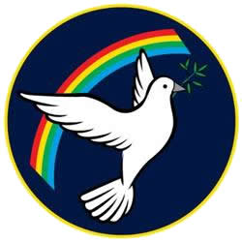 | Lisle Marsden Church of England Academy
 | Year 4 Summer Term 1 LONG TERM PLAN
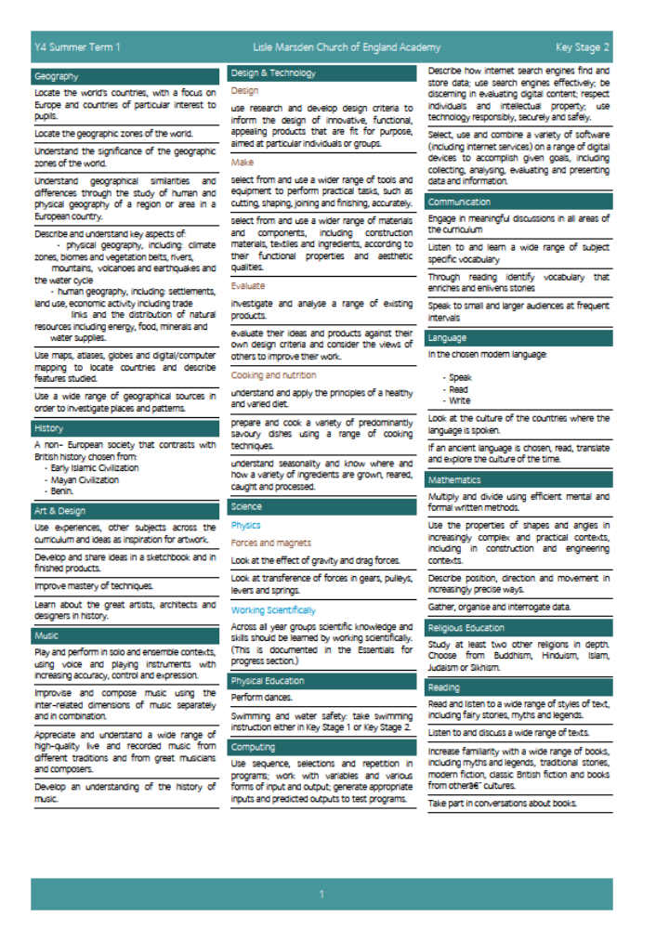

Lisle Marsden Church of England Academy
Year 4 Summer Term 1

Sparkling start  A journey to Morocco – pack your bags |  | A journey to Morocco |  |  |  |  |  |  |  | Fabulous finish  A Moroccan Souk
Big Ideas | As Readers we will be exploring fantasy tales and fictional stories including 1001 Arabian Nights and Aladdin and the 40 thieves. We will be reading a wide range of texts from newspapers, information leaflets, instructions and reports.  As Writers we will be creating stories based on the ones we have been inspired by, in the setting and location of Morocco.  We will retell and re-write our versions of particularly "Aladdin's Wonderful Lamp", "Ali Baba and the Forty Thieves" and "The Seven Voyages of Sinbad the Sailor",  Through KOW we will connect to a school in Morocco and write letters to the children, with questions and examples of life in our school  Kingdom. We will find out about life for children in Morocco through the charity SOS Children’s Village  As Scientists we will study forces and magnets, knowing about gravitational pull and the effect this has on our planet, tides and environments.  As Geographers we will explain the differences through comparing and contrasting the locality of Morocco with the United. We will use atlases, maps and explain the physical differences and similarities using correct geographic language.  We will study the contrasting desert and mountain environments using human and physical geography to understanding and explain why these settlements existed and the risk they face of erosion. |  |  |  |  | As Historians we will discover how Morocco struggled with invasions, became a centre for Early Islamic beliefs and how it was divided up by France and Spain in 1904.  We will compare and contrast the royal family in Morocco to our own. We will explain similarities and differences between the two and study significant kings and queens over time.  We will investigate the ancient caravan routes from the Sahara desert to Marrakesh and study the amazing 17th Century fortress of KSAR OF AIT-BEN-HADDO.  As Language experts we will be studying the French language and the place it holds in Morocco as the gateway between Africa and Europe. We will investigate to find out patterns of French speaking communities throughout Africa and Morocco  As Design Technologists we will discover how to design and make authentic Moroccan food. We will taste and compare our food knowing about the range of spices and flavours through taste tests. An expert panel from the local community will also help us identify what is good with our cooking and how to improve it.  As Artists we will learn and take inspiration from Moroccan art across a range of techniques from woodwork and mosaics discovering the importance of the Islamic 8 pointed star in the designs. We will look for evidence how Moroccan art can be seen in everyday objects in the home and local area.  We will make Moroccan pots and use traditional designs, patterns and techniques to represent authentic pottery.
Further opportunities | Readers: |  | Take inspiration and study maps from stories from the collection of ancient and medieval Arabic and European stories such as particularly "Aladdin's Wonderful Lamp", "Ali Baba and the Forty Thieves" and "The Seven Voyages of Sinbad the Sailor",
Further opportunities | Writers: |  | Use the structure of stories to recreate and retell children’s versions of familiar stories, adding personal twists and dilemmas to capture attention.  Explain, through History and Geography how Morocco has become the place it is today and the significant influences and events that shaped it.
Further opportunities | Communication: |  | Rehearse and retell stories through writing, drama and digital technology to explain imaginary and real events about Morocco.
Further opportunities | Mathematicians: |  | Connect and use the number system, look at the Arabic number system and connect similarities to our own. Study how shape and pattern in Moroccan art is influenced through symmetry and shape.
Curriculum Drivers | In our Spiritual and Moral development we will: |  |  | Through Enquiry we will: |  |  | Through the Arts we will: |  | Through exploring Knowledge of the World we will:
Curriculum Drivers | Understand more about the beliefs and practices of another culture.  We will recognise and tolerate the differences and similarities between Islamic beliefs and our own.  Look for connections between our Christian faith and its origins to that of Morocco. |  |  | Ask questions and find out k=new knowledge about a country that is unfamiliar to us.  Look for patterns and events in Geography and History and explain the effects these have had. |  |  | Take inspiration from the intricate and highly skilled woodwork, mosaics and pottery. |  | Discover a country that is the gateway between Africa and Europe. We will study how Morocco became diverse in people, beliefs and ethnicity through trade routes and environments.
Secrets of Success: Attitudes | Understanding others  • I am keen to seek the opinions of others.  • I ask ‘what can I give?’ to a situation rather than ‘what can I take?’  • I change my behaviour to suit the situation.  • I know that my work or ideas need to have value to other people to be useful. |  |  |  | Try new things  • I enjoy new things and take opportunities wherever possible.  • I have found my Energy Zone – Things I love doing.  • I get involved in clubs or groups.  • I meet up with others who share my interests in a safe environment.  • I know what I am good at, but know there are lots of other things in the world to try out. |  |  | Improve  • I am very clear about what I have done well.  • I quickly spot things that could be improved.  • I seek opinions of others and listen to their comments.  • I work hard at making adjustments to my work.  • I take small steps and know this will get me where I want to be eventually.

Lisle Marsden Church of England Academy: Connecting and sequencing learning
Year 4 Summer Term 1
Sparkling start | A journey to Morocco |  |  |  |  |  | Fabulous finish
Weeks (delete as needed)
Readers
Writers
Mathematicians
Communicators
Scientists
Religious Education
Computing
Design Technology
Geographers
Historians
Musicians
PSHE
Physical Education

