 | Lisle Marsden Church of England Academy
 | Year 5 Spring Term 2 LONG TERM PLAN - * Review Science
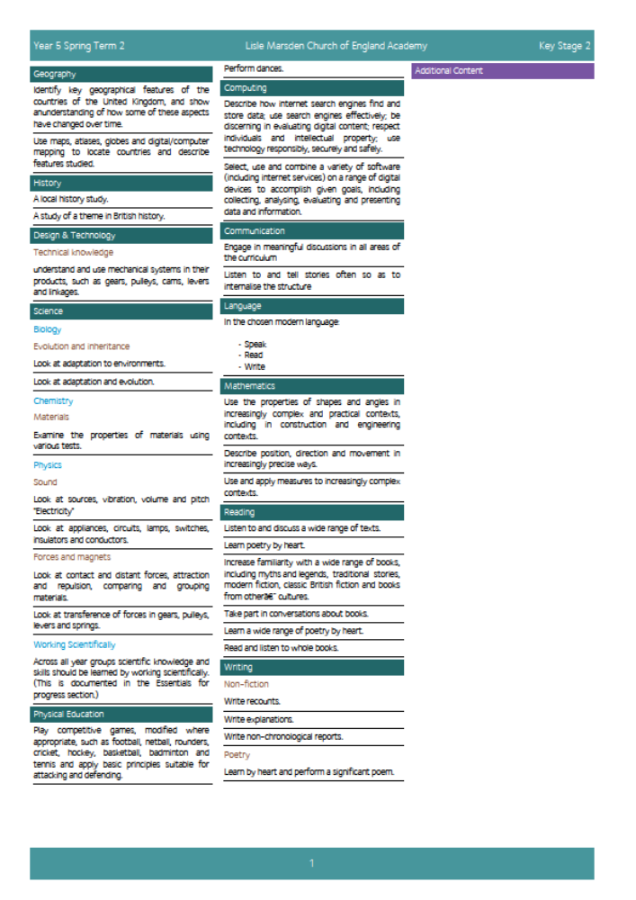

Lisle Marsden Church of England Academy
Year 5 Spring Term 2

Sparkling start  Research, design and make a new invention |  | New era – old v new |  |  |  |  |  |  |  | Fabulous finish  Launch an invention at the LM Trade show
Big Ideas | As Historians, discover who the top inventors in Britain were and what they have contributed to. Study a wide range of significant individuals and inventions over time and sort these in to categories. Explain how some of these inventions have been modified and improved over time. Know when certain inventions were created and their place in time against others.  Explore the headlines of how the British Empire came about, her allies and enemies through time. Explain why the Empire was established and key individuals who were the pioneers.  Through the study of medicine, focus on the Crimean war and the work of nurses, including Florence Nightingale. Explore the methods used today and how they were pioneered in the past.  As Geographers, study the island of Galapagos, identifying the main physical and human geographical features using mapping techniques, use technical language to describe position in the world through longitude, latitude and hemisphere  As Writers explain a selected invention and legacy it has had on Britain and the wider world through creating a profile of inventor and invention. Compare similar inventions and explain the benefits and drawbacks as a result of this invention.  Through visiting a hospital and meeting nurses create a profile of a modern nurse detailing the key points from the visit in a journalistic style using images as well as texts.  As teams write instructions for a fictional new invention. Create an advert on the website promoting the new product. Get feedback from secure voting buttons on how to improve the product.  Using comic strips, create new super hero characters and story boards.  Write and present persuasive arguments for and against the advances in cybernetics using the work of English Scientist Kevin Warwick. |  |  |  |  | As Scientists, study Charles Darwin and his theories and evidence of evolution. Use the Galapagos islands as an example of animals adapting to their habitat and environment.  Ask questions to find answers about how humans have evolved over time. Compare to species that have evolved and those that have not. Study a range of species and explain their success or why they are endangered.  Discover and explain how sound is transmitted through vibration and link to the inventions of Alexander Graham-Bell.  Explore the power and application of magnets and pulleys in inventions throughout the world. Use forces, magnets and pulleys to understand their use in simple structures and inventions.  Study the work of Prof Kevin Warwick at Reading University to discover ethical impact of science through cybernetic advances.  As Design Technologists, discover the 5 steps to a great product. Invent a prototype for a new invention in the kitchen or at home. Use animations, such as Wallace and Grommet to inspire creative design thoughts.  Discover the design advances in para-Olympic sports, prosthetic limbs and cybernetics to highlight innovation for good.  As Computer experts, write code that controls a fictional character. Use code to change motion, looks and sound.  Use digital technology to capture images of inventions over time, create tables and order so they can be sorted easily by a category  As Artists, study the work of Roy Lichtenstein, one of the creators of modern pop art and comics. Create new super hero artwork using similar techniques.
Further opportunities | Readers: |  | Explore a range of non-fiction books and wider sources of evidence to discover new information and share it with others. Read comics and discover the language used to create effect in partnership with images.
Further opportunities | Writers: |  | Explain and justify reasons for inventions, persuading others about ethical challenges such as cybernetics. Create comic strip stories to characterise a newly created super hero.  Publishing a report such as visiting nurses at a local hospital to find out what they do and how they improve themselves.
Further opportunities | Communication: |  | Explain to others why the teams invention is worthy of voting for. Accepting feedback and improving the product as a result.
Further opportunities | Mathematicians: |  | Collecting and sorting data on a range of countries – both European and Non- European.
Curriculum Drivers | In our Spiritual and Moral development we will: |  |  | Through Enquiry we will: |  |  | Through the Arts we will: |  | Through exploring Knowledge of the World we will:
Curriculum Drivers | Appreciate that innovation has good and bad effects. Knowing the effect we have when making a choice. Discuss moral implications of advances in science such as innovation through adversity. |  |  | Ask what if questions to help think creatively. Work collaboratively to spark new ideas and develop lines of thought. Discover knowledge we may find challenging and unbelievable. Through conversation w e will make up our own minds through studying evidence and discussing with others |  |  | Know about Pop Art through the work of Lichtenstein and Lee. We will create comic strips in the pop art style.  Use these styles to support our writing and communication. |  | Study the Galapagos islands and know why Darwin used it as a base for collecting evidence for his theories.  Explore new ideas about cybernetics and speculate about the future of enhanced evolution.
Secrets of Success: Attitudes | Understanding others  • I am keen to seek the opinions of others.  • I ask ‘what can I give?’ to a situation rather than ‘what can I take?’  • I change my behaviour to suit the situation.  • I know that my work or ideas need to have value to other people to be useful. |  |  |  | Improve  • I am very clear about what I have done well.  • I quickly spot things that could be improved.  • I seek opinions of others and listen to their comments.  • I work hard at making adjustments to my work.  • I take small steps and know this will get me where I want to be eventually. |  |  | Try new things  • I enjoy new things and take opportunities wherever possible.  • I have found my Energy Zone – Things I love doing.  • I get involved in clubs or groups.  • I meet up with others who share my interests in a safe environment.  • I know what I am good at, but know there are lots of other things in the world to try out.

Lisle Marsden Church of England Academy: Connecting and sequencing learning
Year 5 Spring Term 2
Sparkling start | New era –old vs new |  |  |  |  |  | Fabulous finish
Weeks (delete as needed)
Readers
Writers
Mathematicians
Communicators
Scientists
Religious Education
Computing
Design Technology
Geographers
Historians
Musicians
PSHE
Physical Education

