 | Lisle Marsden Church of England Academy
 | Year 6 Autumn Term 2 LONG TERM PLAN
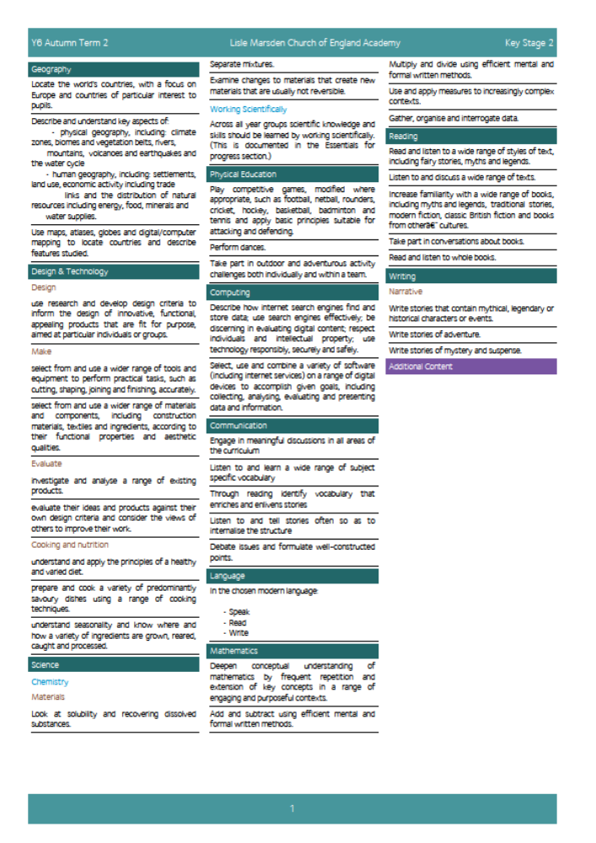

Lisle Marsden Church of England Academy
Year 6 Autumn Term 2

Sparkling start  Survival day using forest schools and local woodlands |  |  | Stormbreaker! |  |  | Fabulous finish  Make a film to explain how to be a survival expert in a chosen location.
Big Ideas | As Geographers, explore a range of extreme locations to identify and communicate the physical geography including terrain and position on a world and local map. Identify settlements (if any) and indigenous populations.  Explain, through posters, how certain geographical features came about such as mountains and volcanoes, their impact on the local environment and resources they give or take from the place.  As readers, reflect on the imaginary world created by Anthony Horowitz and explore the adventurous character - Alex Ryder.  Through enquiry discover and communicate the challenges and conquests modern explorers, such as Bear Grylls, present themselves. Research and explain what it means to be a modern explorer.  http://www.beargrylls.com/  Write biographies of present and past explorers to explain who they were, how they came to be an explorer, their family tree, motivation, resources and successes / failures. Use top trump cards to sort and classify explorers using class agreed criteria.  As historians find out about explorers in the past, their challenges, successes and failures.  Sort information to look for similarities and differences between modern day and previous explorers.  Compare and contrast the equipment available to past and modern explorers. HH Clip here of Scott’s preparation for his fateful polar challenge to South Pole. |  |  |  | As artists, paint portraits and create collages of an explorer, illustrating their talents, ambition and most famous conquest.  Design an exploration mission for a team. Identify the location using maps and compass bearings, reporting on climate, terrain and risks such as avalanches, earthquakes, eruptions, rock falls, getting lost, freezing or over heating.  Experience a challenging orienteering course away from school. See local groups here.  Design, plan and implement a year group orienteering challenge.  As mathematicians plan an adventure, calculating distance, grid reference, time zones, equipment and travel costs.  Through fictional writing, communicate adventurous challenges and successful outcomes with near misses and hair raising situations.  As Scientists discover how to purify and clean water in a variety of different ways. Know and practice how to separate mixtures and soluble substances.
Further opportunities | Readers: | Take inspiration from Horowitz. Discover the structure of biographies and how they convey the story of an individual’s life. Use non-fiction and reference books to sort and classify information.
Further opportunities | Writers: | Construct and write adventure stories using knowledge from non-fiction and reference books to complement and make the reader further engaged.  Design, portray and summarise the life of famous explorer’s through mini biographies and information writing.  As Scientists explain and report the methods and outcomes of tests to separate materials.
Further opportunities | Communication: | Share new knowledge and skills through a group diary or class blog. Prepare weekly updates for the website to keep parents and families informed. Create short film to tell the story of new learning this ½ term.
Further opportunities | Mathematicians: | Use measures, patterns, number, ratios and correct units of measurements to create accurate maps, drawings and explanations.
Curriculum Drivers | In our Spiritual and Moral development we will: |  | Through Enquiry we will: | Through the Arts we will: |  |  | Through exploring Knowledge of the World we will:
Curriculum Drivers | Encourage pupils to explore and develop what animates themselves and others.  Relate the values Bear Gryll’s holds and how he lives his life. Identify spirituality through his visible Christian values.  Recognise and accommodate difference and respect the integrity of individuals.  Ask what attracts and motivates adventurers to take risks and succeed in face of great danger?  Appreciate, compare and contrast different religions in locations |  | Explain how extreme environments came about.  Know about present and past British explorers.  Discover how to survive in forest environments, including shelter, warmth, cooking and basic communication. | Explore impressionist’s paintings through the work of Turner, Claude Monet and watercolours of Sargent.  Nature as an artist through aerial photographs of different environments. |  |  | Know about different regions and features of the UK and the world. Explain using geographic language how they came about over time.  Know about soluble and insoluble materials and how to separate them.  Explain how nature separates materials and filters poisons through reed beds.  Discover challenge terrains within and beyond our world including undersea and outer space.
Secrets of Success: Attitudes | Push yourself  • I find a way to push myself even when things are difficult.  • I push myself in lots of ways… even things I don’t feel like doing.  • I listen to other people who push me, and thank them for their advice.  • I know that pushing myself makes me better at things. |  | Try new things  • I enjoy new things and take opportunities wherever possible.  • I have found my Energy Zone – Things I love doing.  • I get involved in clubs or groups.  • I meet up with others who share my interests in a safe environment.  • I know what I am good at, but know there are lots of other things in the world to try out. |  |  | Don’t give up  •I think of new ways to do things if my first idea doesn’t work out.  •I get upset when I fail, but find ways to bounce back.  •I stick at things even if they are tough.  •I look out for luck and I think I am lucky.

Lisle Marsden Church of England Academy: Connecting and sequencing learning
Year 6 Autumn Term 2
Sparkling start | Shipwrecked! |  |  |  |  |  | Fabulous finish
Weeks (delete as needed)
Readers
Writers
Mathematicians
Communicators
Scientists
Religious Education
Computing
Design Technology
Geographers
Historians
Musicians
PSHE
Physical Education

