 | Lisle Marsden Church of England Academy
 | Year 6 Spring Term 2 LONG TERM PLAN
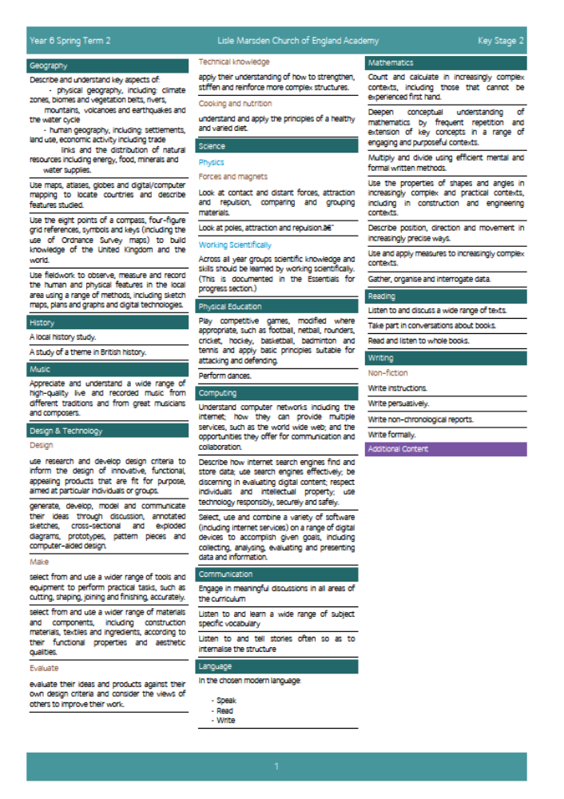

Lisle Marsden Church of England Academy
Year 6 Spring Term 2

Sparkling start  Visit the Eden Camp |  | The Home Front - Evacuation |  |  |  |  |  |  |  | Fabulous finish  Create a news report
Big Ideas | As Readers we will study the diaries of Anne Frank and read the novel Goodnight Mister Tom by Michelle Magorian  As Writers we will communicate our interpretation of what we know it was like (based on evidence) to be evacuated from home through diaries, short stories and non-chronological reports.  We will write letters from our imaginary evacuation to our parents describing the setting, events, characters, including both their and our own hopes and fears.  We will write recipes and instructions to recreate WW2 food, using original methods and ingredients.  As writers we will use persuasive texts to influence groups about topical debates such as supporters of the war or those against it.  As Historians we will discover how life was at home and before, during and after WW2. By constructing a timeline we will be able to plot significant events and connect them to countries, their leaders and their beliefs here  We will use first hand sources of evidence to explain life home and away through visiting the Eden Camp here.  We will become experts in the Blitz era, explaining, using evidence, the strategy by the Germans, the defence by the people of Grimsby and Hull here.  We will compare and contrast life in Grimsby during WW2 to that of Anne Frank in Germany and Holland here. |  |  |  |  | We will explore the relationships and formal alliances between different countries and their reasons for taking sides.  We will map the events of WW1 and WW2 over time and use this to show an understanding of the advances in technology through a short period of time.  As Geographers, we will study the physical and human geographical features of Hull and Grimsby. Overtime we will compare the two to understand why it was an important target during WW2. We will explain how the area was affected during WW2 and why it has the industry of today in place.  As Scientists we will know about magnets and forces including poles, repelling and attraction. Also we will explore gravitational pull between the Earth and an object.  As Design Technologists we will cook and recreate the foods and recipes used in Britain during WW2. Set ourselves cooking challenges to design, make and then taste test the food used in WW2 here. Invite grandparents to evaluate the food and make recommendations to improve it using WW2 resources.  As Artists we will use techniques and images to represent silhouettes of the skylines. We will study artists who told the story of war focusing on line drawings and sketches of Edward Bawden, an official artist in WW2 here.
Further opportunities | Readers: |  | We will read the novel Goodnight Mister Tom and use sections of this to recreate our own stories and recounts of evacuation. We will use many reference books, internet sites and interviews to help us understand the impact of evacuation and the war at home
Further opportunities | Writers: |  | We will write for a wide range of purposes across the curriculum to explain the how the war was reported, propaganda and we will write arguments for and against the war. We will write and evaluate delicious recipes using traditional WW2 foods.
Further opportunities | Communication: |  | We will explain how the war made our area change. We will study how it changed and use news reports to explain a focus of the war at home using the language and terminology of the time.
Further opportunities | Mathematicians: |  | We will use maths as part of design technology, science and geography to measure, calculate and express our understanding of number through using a range of data from the war at home in Grimsby.
Curriculum Drivers | In our Spiritual and Moral development we will: |  |  |  | Through Enquiry we will: |  | Through the Arts we will: |  | Through exploring Knowledge of the World we will:
Curriculum Drivers | Understand and take inspiration from individuals such as Anne Frank to help those in need, whilst placing themselves at great risk. Explore the moral and ethical reasons for helping others.  Know that despite conflict, faith remains a guiding principle for the way treat others and knowing actions have consequences. |  |  |  | Ask questions that interest us about evacuation and the war at home. We will collect and use valid and reliable data  Analysis – separating fact from opinion.  Presentation |  | Study artists and explore different techniques that represented the war at home.  Use drama and digital recordings to communicate our messages.  Dance and learn swing and Jazz techniques |  | Explain in depth how our local area was affected during WW2.  Compare and contrast our town with those in other countries. Explain using human, physical and historical terms how they have changed.  Know about similar towns and cities that were affected in WW2. Accurately describe their location and features.
Secrets of Success: Attitudes | Understanding others  • I am keen to seek the opinions of others.  • I ask ‘what can I give?’ to a situation rather than ‘what can I take?’  • I change my behaviour to suit the situation.  • I know that my work or ideas need to have value to other people to be useful. |  |  | Don’t give up  • I think of new ways to do things if my first idea doesn’t work out.  • I get upset when I fail, but find ways to bounce back.  • I stick at things even if they are tough.  • I look out for luck and I think I am lucky. |  |  |  | Work hard  •I have fun working hard.  •I know that by working hard I will be successful.  •I keep practising even when I am good at something.  •I encourage others to work hard.  •I give my best effort to everything I do. |  | Try New Things  • I enjoy new things and take opportunities wherever possible.  • I have found my Energy Zone – Things I love doing.  • I get involved in clubs or groups.  • I meet up with others who share my interests in a safe environment.  • I know what I am good at, but know there are lots of other things in the world to try out.

Lisle Marsden Church of England Academy: Connecting and sequencing learning
Year 6 Spring Term 2
Sparkling start | The Home Front - Evacuation |  |  |  |  |  | Fabulous finish
Weeks (delete as needed)
Readers
Writers
Mathematicians
Communicators
Scientists
Religious Education
Computing
Design Technology
Geographers
Historians
Musicians
PSHE
Physical Education

