 | Lisle Marsden Church of England Academy
 | Year 3 Spring Term 1 LONG TERM PLAN
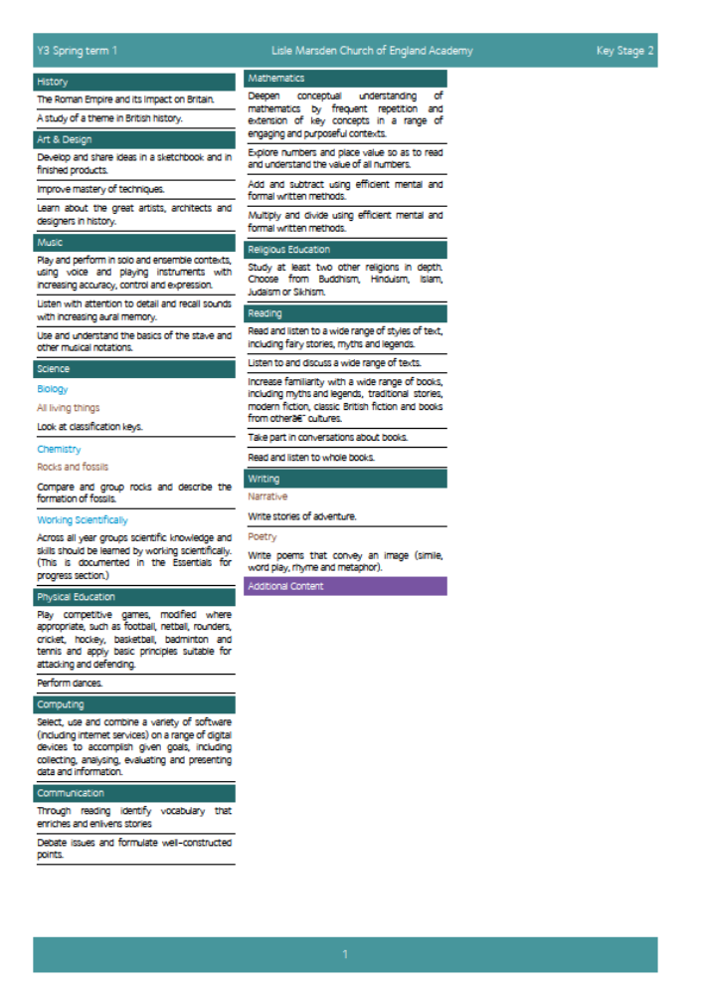

Lisle Marsden Church of England Academy
Year 3 Spring Term 1

Sparkling start  The big dig |  |  | Awesome Archaeology |  |  |  |  | Fabulous finish  Curators of an Art Museum / Gallery
Big Ideas | Time detectives – Knowing about today.  As Historians recognise and articulate the world we live in today using experiences from our own lives and researching the lives of different people in a range of places. What is it like, what facilities do we have that would life really hard to live without?  Describe the features common to living in modern, democratic Britain. As detectives use both primary and secondary sources of evidence to explain this.  As Artists research and explain what life is like in modern Britain through studying the work artists such as Lowry and the Painting of Modern Life. Compare and contrast with life today. What is similar and different?  As researchers ask the question: How will people from the future know how we lived? What will they say about our government, way of life, homes, schools, travel, buildings, jobs, habits, beliefs and religions, stories, music and art? How will they know?  Explore the time capsule project. What would you leave now to explain life today?  As writers, describe life in modern Britain through a letter to an unknown reader. Select items that you would leave to tell a story to help Archaeologists in the future understand how we lived today.  As historians discover the skills that archaeologists require to accurately piece together the story of the past using artefacts and remains, explaining life in that period of time. |  |  |  | Discovering the past  As Historians pose and answer the question: What evidence do we have today that tells us about the changes the Romans made during their time in Ancient Britain?  Like the Time Team, establish an investigation centre to showcase our questions and visibly display our thinking and answers.  Identify significant periods of time and explore the evidence of life in Iron Age Britain. What do we know, what questions do we have? Ways to find out more and what new learning we have? (KWFL) Use matching criteria such as government, way of life, homes, schools, travel, buildings, jobs, habits, beliefs and religions, stories, music and art.  Use primary and secondary sources to begin to build an evidence base to show how life in Britain changed through the invasion of the Romans. (KWFL)  Compare and contrast the evidence collected from what we know about the Iron Age, Roman and Modern Britain. Explain visible similarities and differences.  Study the tragedy at Pompeii. Discover how we know about the past through stories, primary sources including remains, letters and first-hand accounts.  As the Time Detectives, accept the challenge to go further back in time and use evidence of fossils to explain the past.  Study the life and finds of Mary Anning in Lyme Regis.  As geographers, scientists and Historians discover the way fossils come about and how experts use them to tell stories of the past.
Further opportunities | Readers: | Understand and draw conclusions or questions from studying primary and secondary sources of evidence.  Explore non-fiction and reference books to find out about the past.  Enjoy reading and retelling myths and legends from ancient times including the Romans
Further opportunities | Writers: | Construct letters to explain life in modern Britain today.  Write recounts of invasions by the Romans from a range of view-points.
Further opportunities | Communication: | Present information to showcase new learning and enable further questions to be asked. Use digital technology to explain answers to questions. Design an art Gallery to tell the story of the impact the Romans had on Iron Age and Modern Britain.
Further opportunities | Mathematicians: | Explore how Romans used number and the Abacus. Use Roman numerals and crack codes using time. As archaeologists, measure accurately using a wide range of tools and scales to deduce information from the past.
Curriculum Drivers | In our Spiritual and Moral development we will: |  |  | Through Enquiry we will: | Through the Arts we will: |  | Through exploring Knowledge of the World we will:
Curriculum Drivers | giving pupils the opportunity to explore values and beliefs, including religious beliefs, and the way in which they impact on peoples’ lives  Understand that Ancient civilisations believed in and worshipped many Gods.  Discover how Christianity influenced the Roman culture. |  |  | Explain and take a view of modern Britain.  Compare and contrast common aspects of our lives to that of Roman and Iron Age civilisations.  Explain the influence, evidence and legacy these have had on our lives. | Study great artists such as Lowery.  Explore Roman art including Mosaics, cloths, portraits, paintings pottery and sculpture.  Compare Iron Age, Roman and Modern Art. Discover similarities and connections. |  | Discover and connect our lives with those of Roman and Iron Age times.  Link places and remains to the past, knowing why they were built and how they were discovered, leading to what can they tell us about life then.  Know how fossils are formed and the evidence they leave us. Study the life and finds of Mary Anning.
Secrets of Success: Attitudes | Concentrate  • I focus on what I am doing, giving my full concentration.  • I ‘tune out’ distractions.  • I know what helps me to concentrate.  • I check that I am doing is what is required.  • I am becoming an expert at some things. |  |  | Improve  • I am very clear about what I have done well.  • I quickly spot things that could be improved.  • I seek opinions of others and listen to their comments.  • I work hard at making adjustments to my work.  • I take small steps and know this will get me where I want to be eventually. |  | Try new things  • I enjoy new things and take opportunities wherever possible.  • I have found my Energy Zone – Things I love doing.  • I get involved in clubs or groups.  • I meet up with others who share my interests in a safe environment.  • I know what I am good at, but know there are lots of other things in the world to try out.

Lisle Marsden Church of England Academy: Connecting and sequencing learning
Year 3 Spring Term 1
Sparkling start | Awesome Archaeology |  |  |  |  |  | Fabulous finish
Weeks (delete as needed)
Readers
Writers
Mathematicians
Communicators
Scientists
Religious Education
Computing
Design Technology
Geographers
Historians
Musicians
PSHE
Physical Education

As mathematicians use time, distance and measurement to plan journey’s locally and regionally.
Compare different ways and time / cost of getting to a location using agreed methods such as walking, cycling, driving, rail and air.

