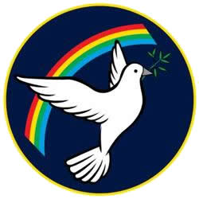 | Lisle Marsden Church of England Academy
 | Year 3 Summer Term 1 LONG TERM PLAN
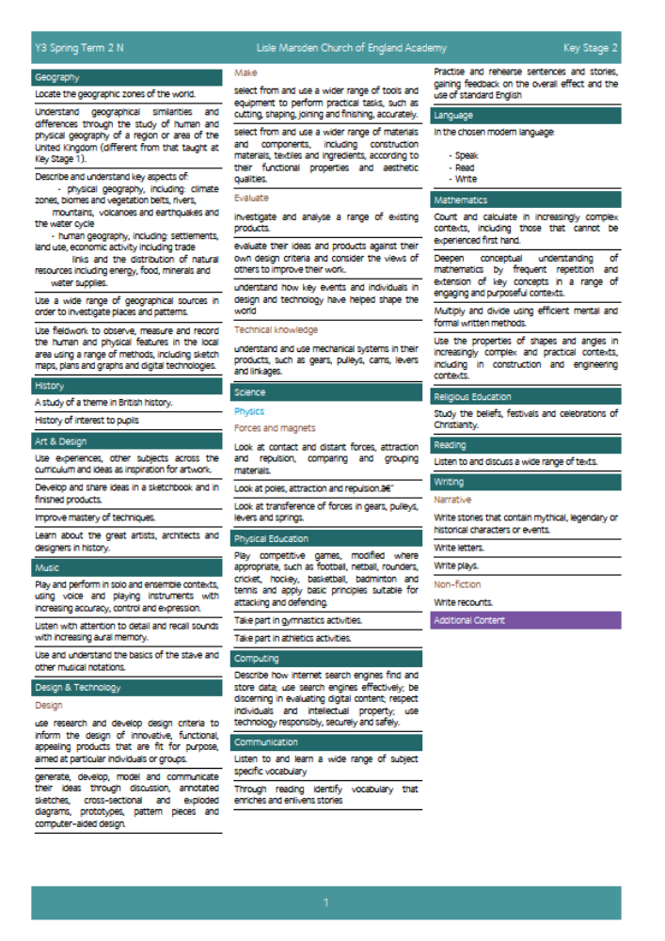

Lisle Marsden Church of England Academy
Year 3 Summer Term 1

Sparkling start  Journey around the globe |  | Passport to the world |  |  |  |  |  |  | Fabulous finish  World fair
Big Ideas | As Writers we will be communicating information about ourselves in a passport. We will use a range of structures to convey writing clearly - such as headings, subheading and paragraphs to present the information accurately.  We will be writing non-fiction books, using explanations and report writing to show what we know and what we want to find out.  We will also be mapping fiction books s to help us create really interesting adventures stories.  We will compare stories that are familiar to us from around the world, recognising the similarities and differences in the characters, language and illustrations  Hugh Lupton – The Story Tree.  As Readers we will study information leaflets and brochures to know how to convey information about a place.  We will communicate our knowledge of a country through studying agreed common elements such as the national flag, physical and human geography.  As Mathematicians we will be gathering data from different countries and using it to help explain why the country is like it is. Statistics focusing on physical geography such as mountain heights, river lengths and human geography such as number of people in main cities will be compared across the globe.  As Scientists we will be studying how plants work, which ones are indigenous and how they adapt to their environments  As Artists we will be studying great artists from our chosen country, replicating their style and techniques with our own interpretations. |  |  |  | As Geographers we will be studying a locality in the world that is very different to our own locality. We will be looking at maps of the world, learning to name the continents, major countries and oceans. We will be finding out where some of our favourite foods come from and finding out how they get to this country. We will also find out about the climate of some of the places food comes from.  We will be presenting this in the most interesting ways we can and will include our findings in the books we have made.  We will be locating and mapping countries of Europe as well as discovering geographic zones / weather and climate  As Designers we will be tasting different types of bread and fruit smoothies. We will learn how to make our own by learning to prepare food safely and hygienically. Then we will get a chance to choose which we would like to make for ourselves. We will be asked to design the recipe and make the whole thing from start to finish. We will then give our foods the ‘taste test’, to see if they could be improved.  We will also be making photograph frames to display a favourite picture, capturing the eye of the school through imaginative and practical design techniques. We will be presenting our frames to the school to find out which aspects they like and how we can improve them.  As Musicians we will study a variety of traditional world music and dances, as well as composing and playing our own.  As Computer experts we will use the internet cleverly and look for more than one source of evidence to ensure reliability. We will also be using digital images within art and writing.
Further opportunities | Readers: |  | Sources of evidence, non-fiction books, reference books, atlases and globes.  Multicultural stories from around the world
Further opportunities | Writers: |  | Stories from around the world, reporting and sharing new understanding from our chosen place through explain what a place is like and the culture of the people who live there.
Further opportunities | Communication: |  | We will be taking the opportunity to present our understanding of countries around the globe to a larger audience. We will use digital, written, painted media to share what we now know.
Further opportunities | Mathematicians: |  | Collect data from a range of places and people and use it to tell what we know and ask further questions.  Use numbers over 1000 to represent distance travelled and areas of countires.  Compare and explore ratio and proportion linked to the local area vs a new country or region.
Curriculum Drivers | In our Spiritual and Moral development we will: |  |  | Through Enquiry we will: |  | Through the Arts we will: |  | Through exploring Knowledge of the World we will:
Curriculum Drivers | • recognising and respecting the codes and morals of the different cultures represented in the school and wider community;  • encouraging pupils to take responsibility for their actions; for example, respect for property, care of the environment, and developing codes of behaviour;  • providing models of moral virtue through literature, humanities, sciences, arts, assemblies and acts of worship;  • an ability to distinguish right from wrong, based on a knowledge of the moral codes of their own and other cultures; |  |  | Explore the wider world, following lines of enquiry that are of interest to pupils.  Ask questions and use a range of resources such as books, interviews, internet, google earth to find answers and evidence to explain our understanding |  | Discover the artwork that represent the county groups of pupils focus on.  Begin to compare, contrast and explain the differences in art across different cultures  Practice and rehearse dance and music to appreciate the culture of our chosen countries. |  | Know about many different countries through their connection to climate, regions of the world, continents, oceans, longitude and latitude.  Explore and appreciate the variety of environments that cover our globe.  Understand deeply about the people who live in a place and why they hold their beliefs and values
Secrets of Success: Attitudes | Understanding others  • I am keen to seek the opinions of others.  • I ask ‘what can I give?’ to a situation rather than ‘what can I take?’  • I change my behaviour to suit the situation.  • I know that my work or ideas need to have value to other people to be useful. |  |  | Try new things  • I enjoy new things and take opportunities wherever possible.  • I have found my Energy Zone – Things I love doing.  • I get involved in clubs or groups.  • I meet up with others who share my interests in a safe environment.  • I know what I am good at, but know there are lots of other things in the world to try out. |  |  | Concentrate  • I focus on what I am doing, giving my full concentration.  • I ‘tune out’ distractions.  • I know what helps me to concentrate.  • I check that I am doing is what is required.  • I am becoming an expert at some things.

Lisle Marsden Church of England Academy: Connecting and sequencing learning
Year 3 Summer Term 1
Sparkling start |  |  |  |  |  |  | Fabulous finish
Weeks (delete as needed)
Readers
Writers
Mathematicians
Communicators
Scientists
Religious Education
Computing
Design Technology
Geographers
Historians
Musicians
PSHE
Physical Education

